**ICE 7**

id:7   
name: Harshil Patel

**objective**

1. using GOPI pin on Raspberry Pi to blink LED using node-red.
2. using physical button with raspberry pi and node-red.
3. calling python script from node-red on raspberry pi.
4. Send tweet from Raspberry Pi.

**workflow**

**CKT diagram**

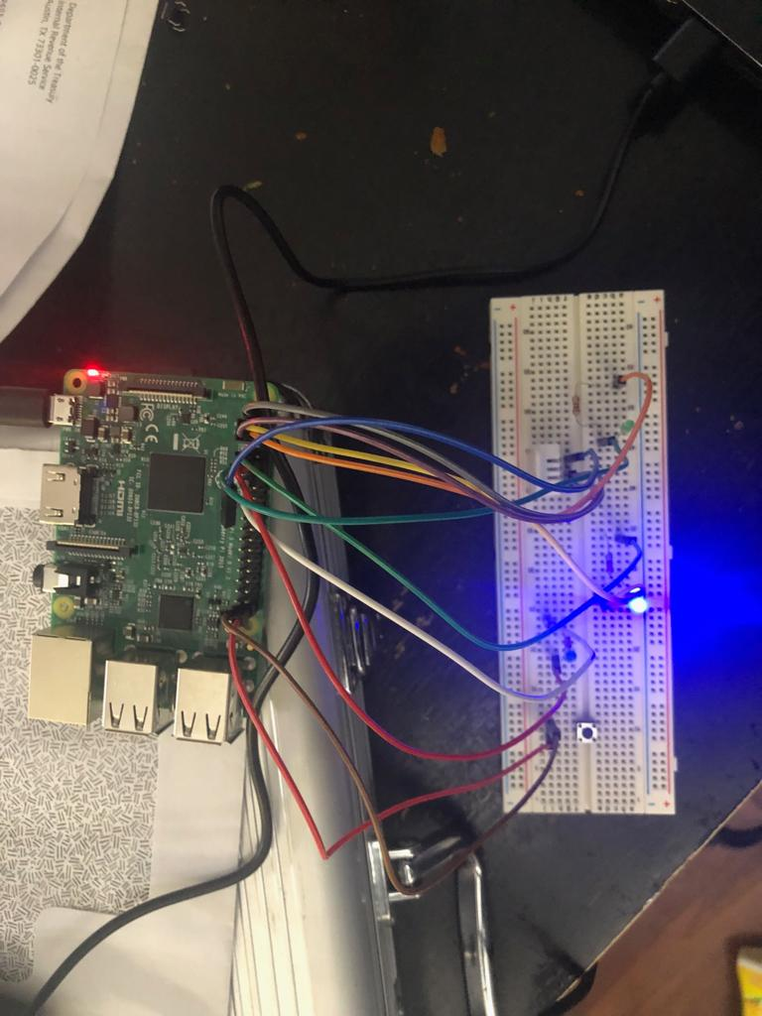

**blinking led**

turn on and off LED light connected with raspberry pi using node-red 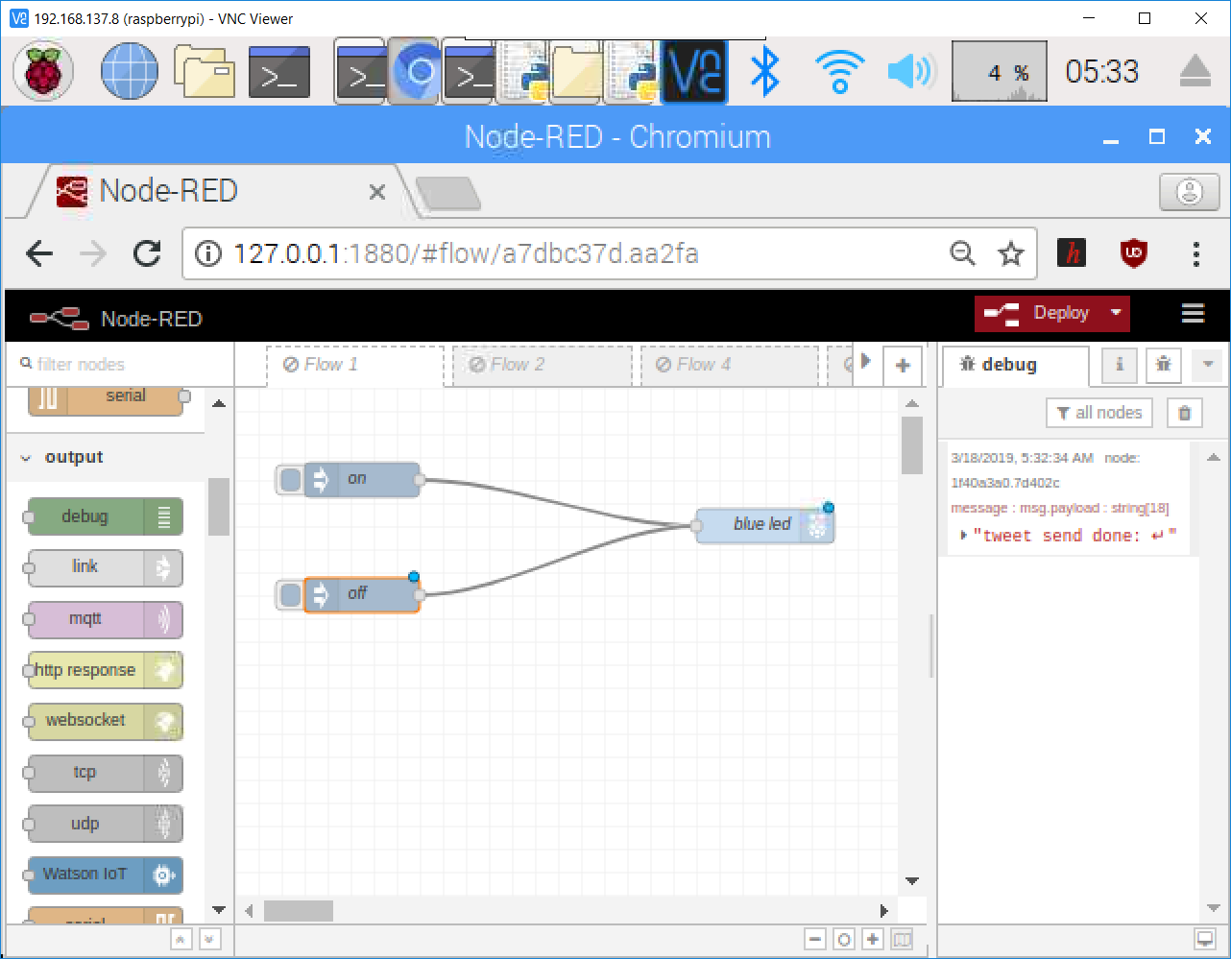

**button-LED**

turn on and off LED light connected with raspberry pi using node-red and a pysical buttton 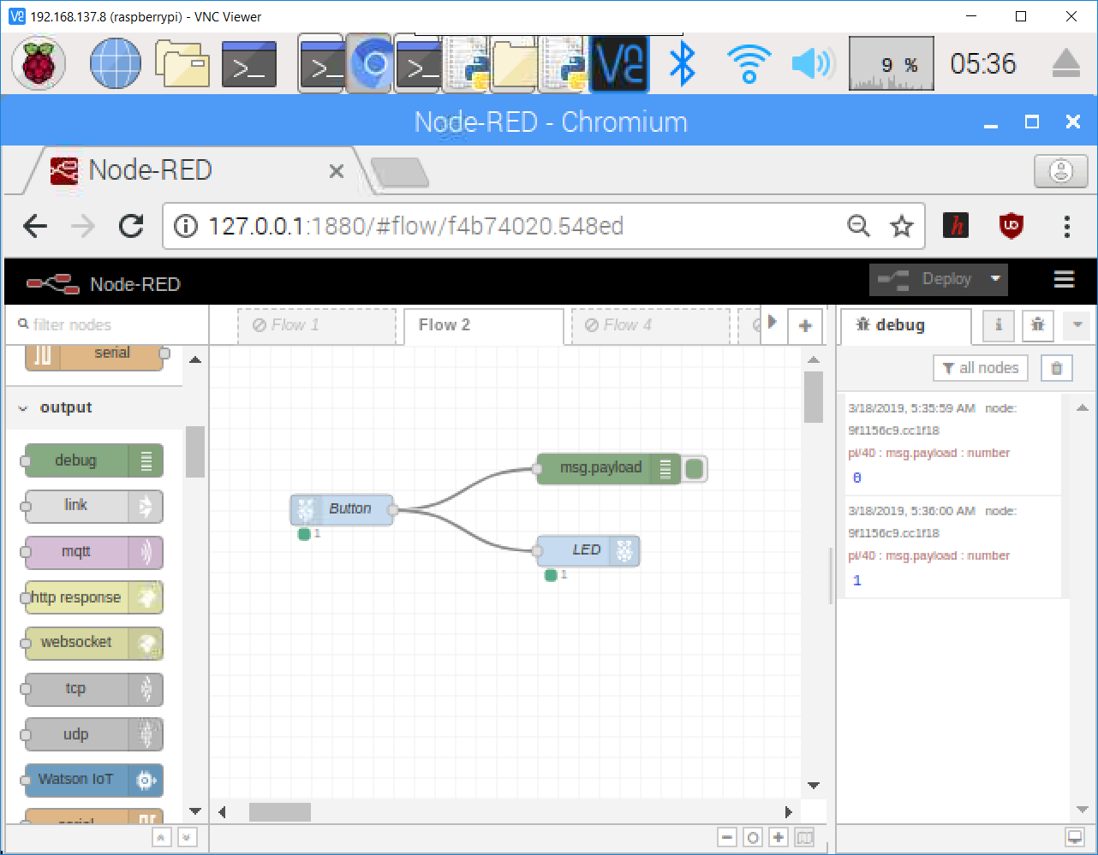

**traffic light**

simulate traffic light using raspberry pi and node-red. 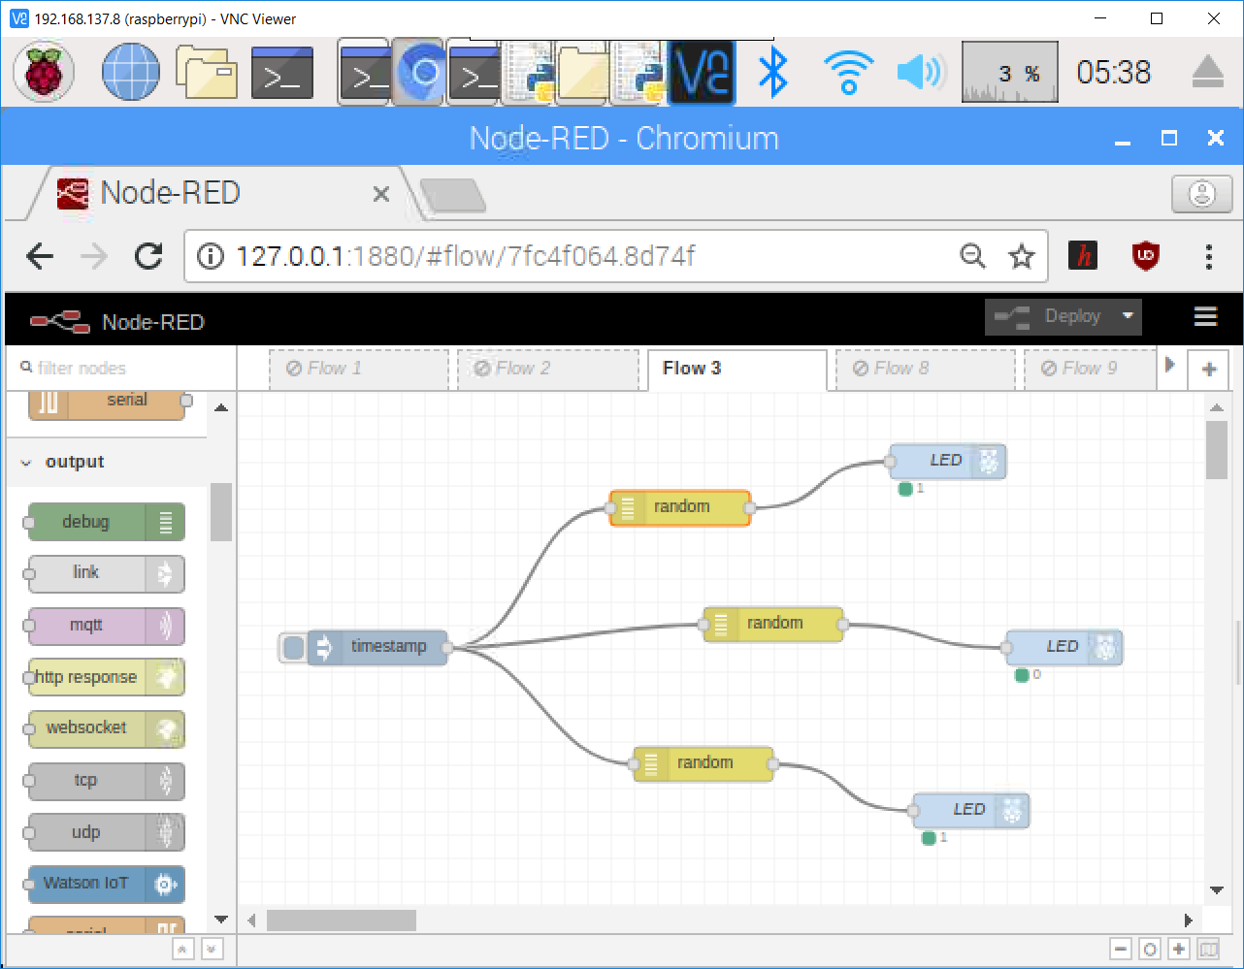

**rasberry pi - tweet**

sending message from node-red to raspberry pi and the sending that message to twiiter using a python script. 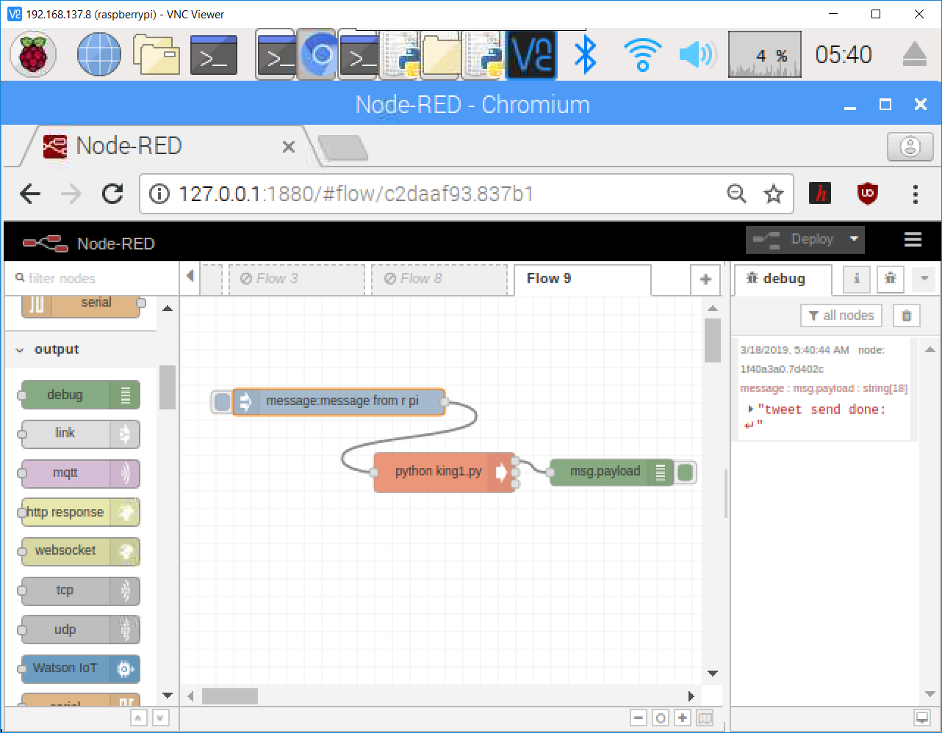

**code tweeting**

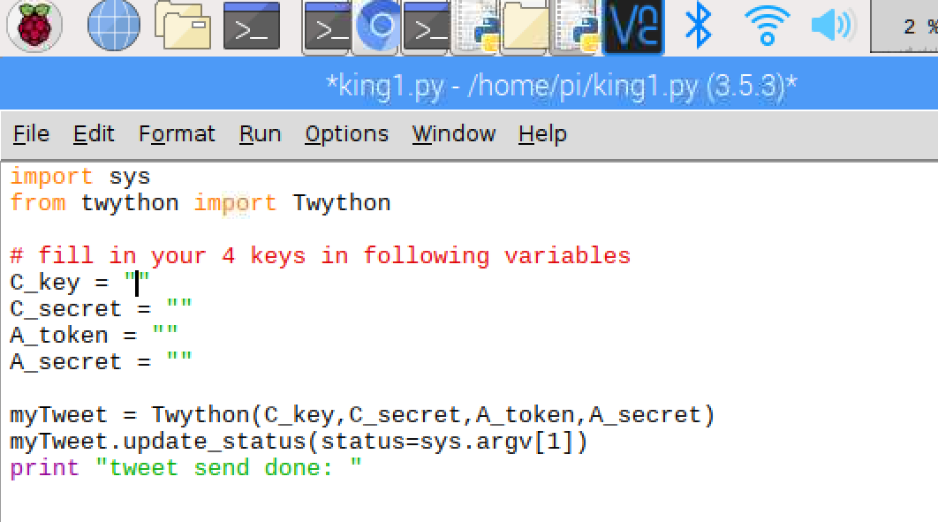

**rasberry pi - tweet**

directly sending message to twitter from node-red running on rasberry pi. 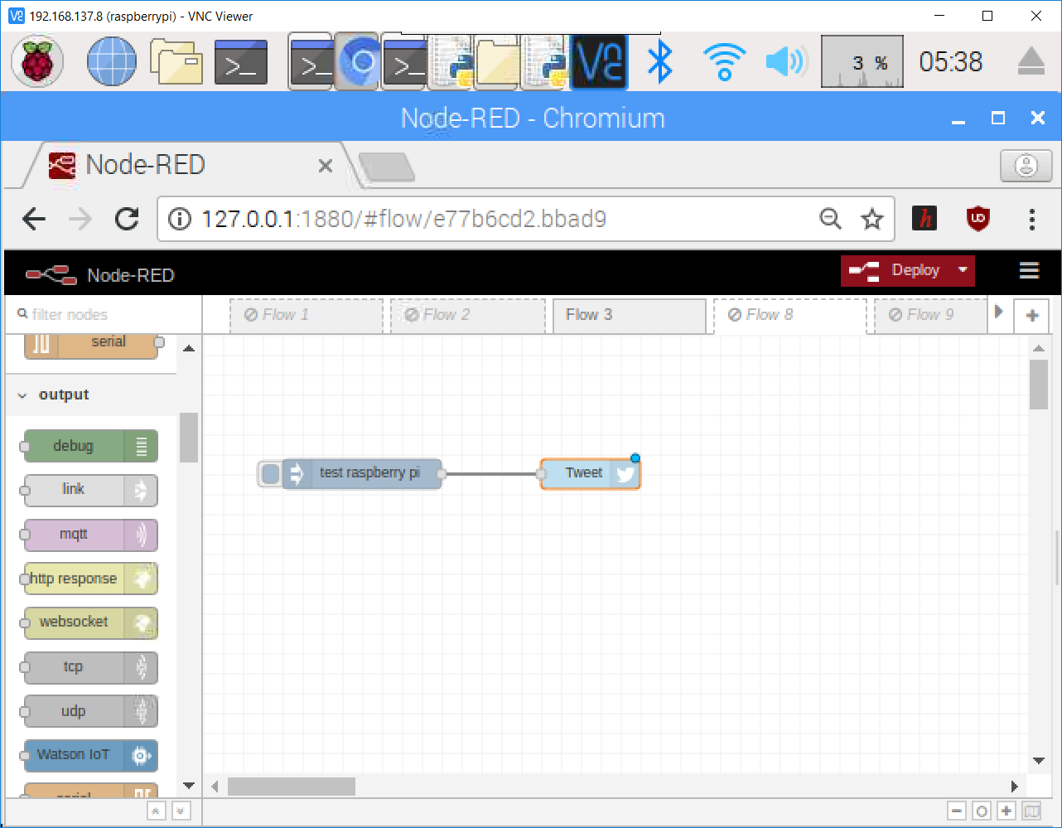

**conclusion**

with the help of this assignment we where able to learn...

1. using GOPI pin on Raspberry Pi to blink LED using node-red.
2. using physical button with raspberry pi and node-red.
3. calling python script from node-red on raspberry pi.
4. Send tweet from Raspberry Pi.